DECKON PREMIUM METAL CEILINGS
BANDRASTER SYSTEM
DATASHEET

Technical Info:

Product : aluminium or galvanised steel
Sizes : 600x600mm, 300x600mm, 600x1200mm std
Thickness : 0.50 - 0.70 mm
Surface : electrostatic powder coated
Perforation : none or ∅1.8-2.5mm hole diameter with 10-50-100mm bordure
Suspension sys : bandraster profile 50-75-100-125-200mm.
Edge detail : 20-30mm up-turns, as specified
Fire Resistance : class A as steel
Color : RAL 9016 - standard white or desired RAL colors

Specification:
A modern and crea ve ceiling system where panels are allowed to rest on C bandraster pro les with the width size from 100mm to 200mm and length up to 3000mm, providing straight and aesthe c look as well as sharp levelling the panels with the grid pro les. All panels are demountable manually without any special tool so that the system enables fast and easy access to the ceiling void.
VISUAL
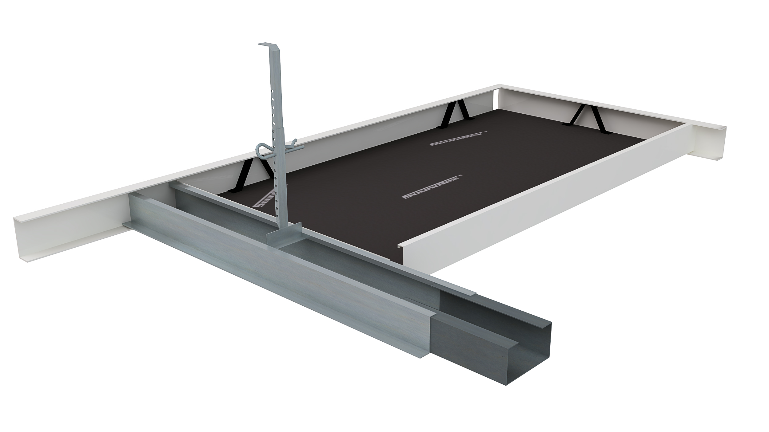
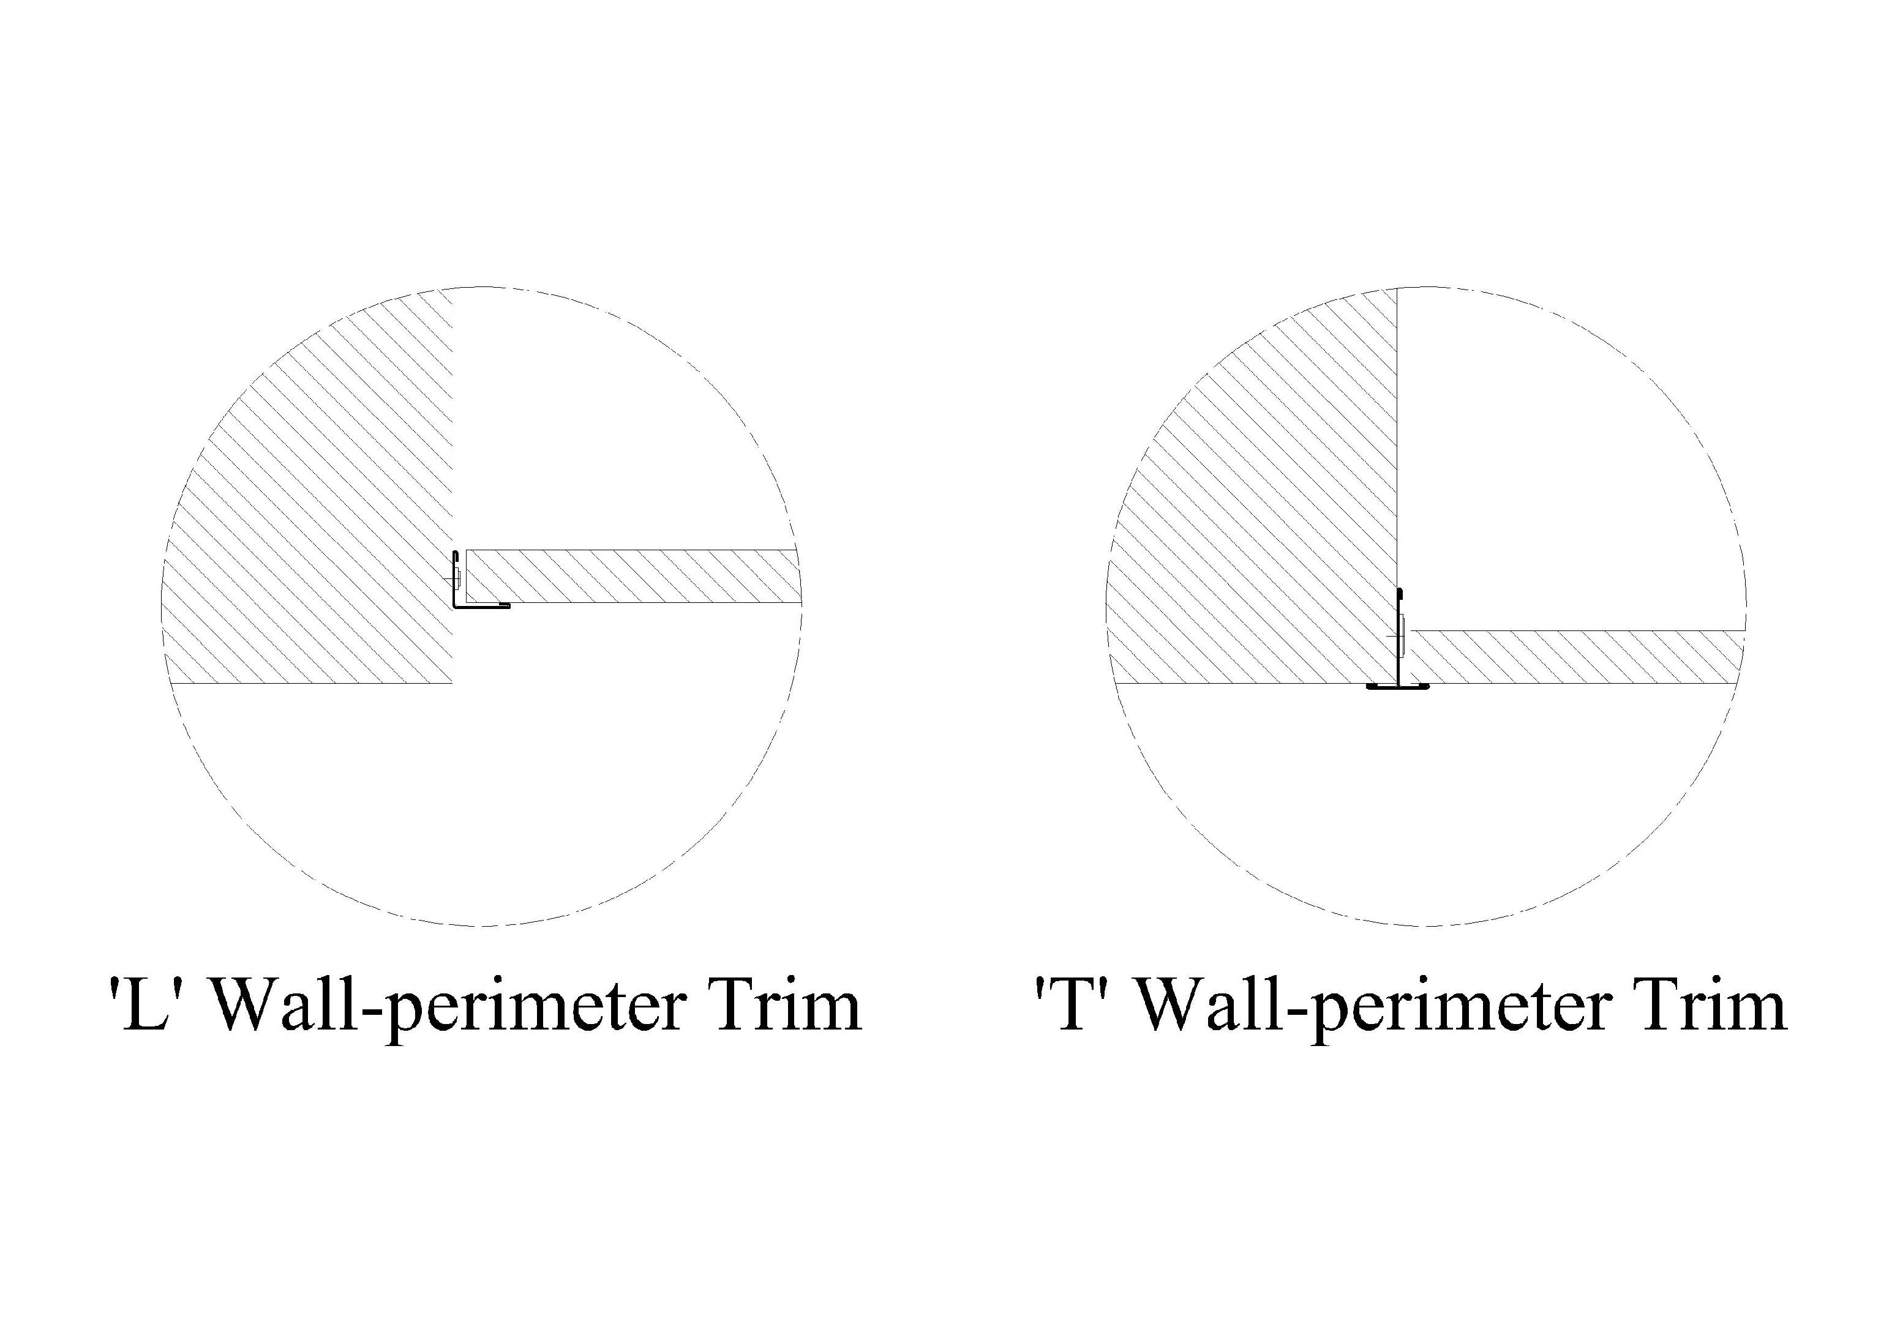
PERFORATIONS 